Firstly open Developer Tab 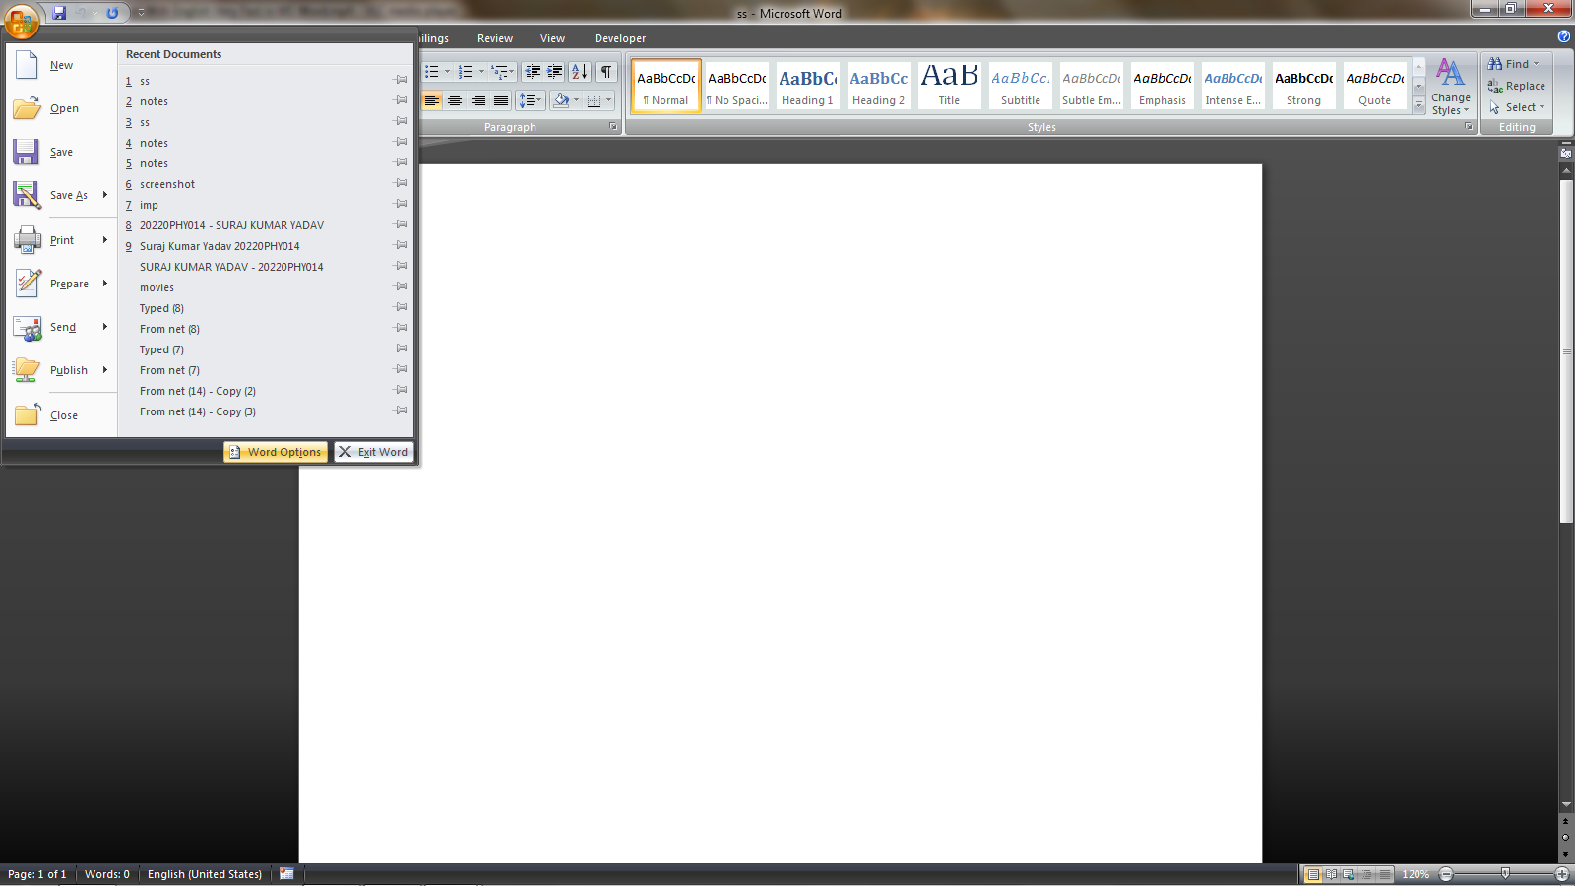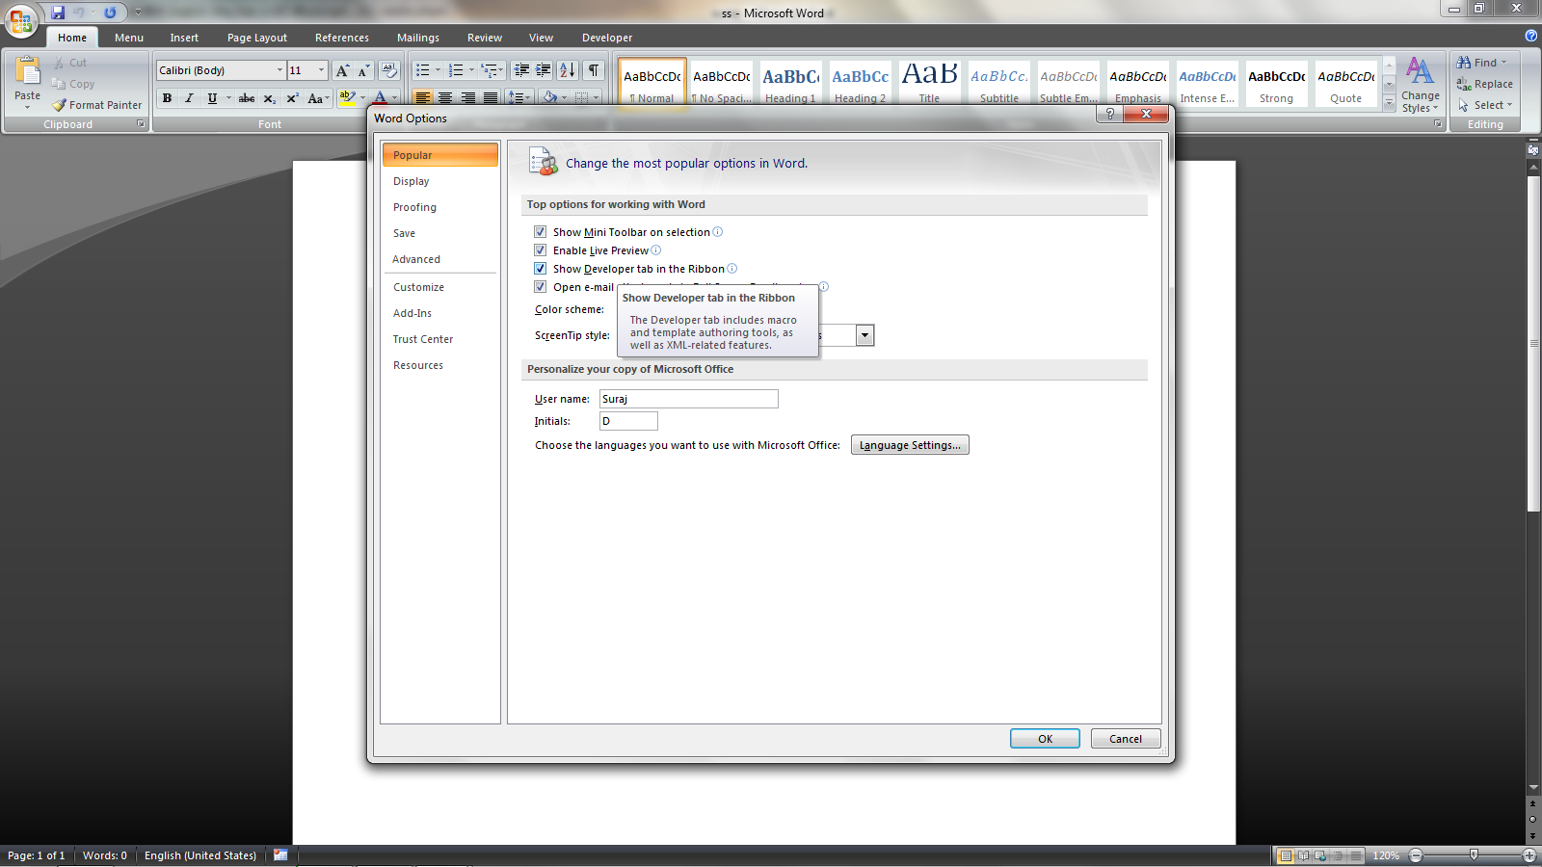click OK
Then record macro to change font in hindi or English and assign a shortcut key

